**Kansas Disability Caucus Pre-Conference Registration**

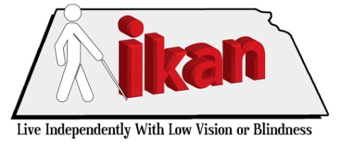**iKan so can you –**

**Delivering IL skills training to individuals who are Blind or visually impaired**

**iKan** is funded by a contract from Kansas Rehabilitation Services (KRS) which enhances the services to individuals who are 55 years or older and blind or have low vision. The contract was awarded to PILR who has subcontracts with RCIL and SKIL. These Centers for Independent Living cover 76 of the 105 counties in Kansas; the remaining counties are covered by Alphapointe and Envision.

Before KRS awarded contracts to PILR, Alphapointe and Envision, the state had a program called KAN-SAIL (Kansas Seniors Achieving Independent Living) that served individuals who were 55 years and older and blind or had low vision. KAN-SAIL was based out of Topeka with two representatives that covered all 105 counties. The KAN-SAIL program and name have been retired and letters have been sent to all their consumers with a referral to the contractor in their area.

As part of the contract provided by KRS, iKan agreed to design an instructional manual on how to deliver IL Skills training to individuals who are blind or have low vision and deliver a training of the trainers at the Kansas Disability Caucus Pre-Conference.

**Who should attend this conference**: Direct Service staff at Centers for Independent Living, Area Agencies on Aging, VR Counselors, Contractors of VR services, Mental Health Centers and any other interested service provider.

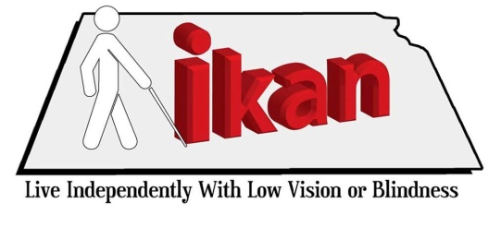**Kansas Disability Caucus Pre-Conference Agenda**

August 9th

11:30 am- 12:30 pm - Registration

12:30 pm- 5:30 pm - How can service providers better serve individuals who are blind or have low vision? Topics include: Advocacy, Peer Counseling, Information and Referral and Deinstitutionalization.  
  
August 10th

8:30 am-12:30 pm – How do independent living skills differ for people who are blind or have low vision?

**Assistive Technology for Kansans** and **NanoPac, Inc.** will have equipment set up for a hands-on display.

**Come learn about what causes blindness and low vision, learn proper etiquette, what IL skills we can deliver and how to deliver them, and practice and learn about Assistive Technology.**

**Kansas Disability Caucus Pre-Conference Registration**

**iKan so can you –**

**Delivering IL skills training to individuals who are Blind or visually impaired**

Please fill out the form below to register for the Pre-Conference, which will take place August 9-10 at the Capitol Plaza Hotel in Topeka.

**Please Note: You will need to fill out a separate registration form for the Disability Caucus.** On that registration, please state that you plan to attend the Pre-Conference and your arrival date is August 9.

**Name: ______________________________________________________________________**

**Organization: ________________________________________________________________**

**Address: _____________________________________________________________________**

**Phone: ______________________________________________________________________**

**Staying at the Capitol Plaza? _____Yes _____No** Rooms are $80/person/night. Your reservations will be made for you if you mark yes, please include a check payable to PILR with your registration form.

**Please mark any of the following you will need to participate in the training:**

_____Braille _____Large Print _____Audio CD _____ Text CD

_____Sign Language Interpreter _____CART

**Center for Independent Living? _____Yes _____No** (If No, please provide a $90 check, payable to PILR, 17 S. Main, Hutchinson, KS 67501)

Registration forms are due by **July 8, 2011**. This form can either be emailed to cireland@pilr.org or mailed to PILR at 17 S. Main, Hutchinson, KS 67501.

If you have any questions about this form or the Pre-Conference, please call PILR at 620.663.3989s.