Register Now!!!


Kansas ONLINE! Disability Caucus

August 12-14, 2020

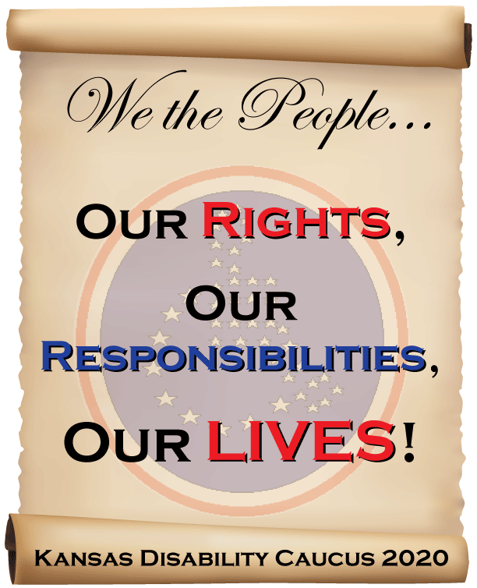

2020 KANSAS ONLINE! DISABILITY CAUCUS

A BIT OF A CHANGE…
This year’s Kansas Disability Caucus is still happening, but will look just a bit different! This year, due to the COVID-19 pandemic and the need for social distancing, a shorter Caucus will be held ONLINE! The Caucus will still occur on the originally planned dates of August 12-14, 2020, but all sessions will occur on Zoom. The two best parts? You get to attend from the comfort of your own home or office, and attendance is FREE! While we wish that we could have the Caucus in person, the safety and health of attendees is our main goal. So, having Caucus sessions online is our safest and best option this year.

HISTORY, BACKGROUND, AND THEME
People with all types of disabilities, of all ages, representing every county of the State, are invited to attend the Caucus. The purpose of the Kansas Disability Caucus is to provide opportunities for Kansans with disabilities to learn, share, and provide solutions to issues faced by the disability community.

In 1988 ninety people attended the first Kansas Disability Caucus in Salina, KS. The outcome of these individuals coming together was a united effort to pass the first consumer directed personal care assistance program in Kansas. It has been common to have leaders in the disability rights movement, such as Ed Roberts, Andy Imparato, and Kelly Buckland, speak at the Caucus in the past.

One of the important pieces of the KS Disability Caucus has always been to have participants divide into three regions where we gather their concerns on issues or barriers to their independence and potential solutions that they may have. While this Caucus will be online, participants will still, at one point, divide into regions and share issues, concerns, and solutions regarding the COVID-19 pandemic. As this is an election year, participants will also be able to get information about the voting rights of people with disabilities and the importance of voting.

This year is also the 30th Anniversary of the Americans with Disabilities Act (ADA). When looking at before and after the ADA became law, many changes have happened to improve life for people with disabilities. There is much to celebrate! While celebrating the advancements, we must also recognize the barriers that still exist. With the recent COVID-19 pandemic, we are seeing that barriers definitely exist regarding people with disabilities and their health. The Kansas Disability Caucus believes the strength of the voice of the disability community is in the power of our VOTE at elections. We must breathe power into the grassroots of our community to get people with disabilities and our supporters registered to vote. We must educate people about the issues and solutions. Then we need to get out to vote! In light of this, the online Caucus sessions will focus on voting and issues arising from the COVID-19 pandemic. Join us for information and discussion on these very important topics!

2020 KANSAS ONLINE! DISABILITY CAUCUS

We the People: Our Rights, Our Responsibilities, Our Lives!

Zoom Online Session Schedule

● Wednesday, August 12, 2020 

10:00 a.m. – 10:30 a.m. KEYNOTE:
Keri Gray
Keri is the Senior Director of Stakeholder Engagement and Strategic Communications at the American Association of People with Disabilities (AAPD) in Washington, D.C. Prior to AAPD, she worked as the Director of NextGen Initiatives at Disability:IN. Additionally, Keri worked with the National Council on Independent Living and consulted with many organizations and institutions of higher education. Keri began her disability work by participating in AAPD’s summer internship program. Keri is passionate about diversity and inclusion. She promotes working where many cultures work together to improve life for people with disabilities.

11:00 a.m. – 12:30 p.m. SESSION:
“Voting: More Than a Box on a Ballot” – Stephanie West-Potter
Voting is a right that also comes with responsibilities. To make a change, we must educate ourselves, our community, and the candidates running for office about what matters to us. In this session, participants will learn about the key issues facing the disability community, understand what media bias is and how to fact check information, discover ways to participate in the political process and communicate with candidates, and feel empowered and fired up to vote on November 3rd.

1:00 p.m. – 2:30 p.m. SESSION:
“Voting Rights” – Disability Rights Center staff (Rocky Nichols, Executive Director; Mike Burgess, Director of Policy and Outreach; Karlie Bischoff, Communications and Outreach Director)
In this session, the speakers will share information regarding the voting rights of people with disabilities in Kansas. They will discuss the confusing photo ID process in Kansas that can be a barrier to the voting process, and the condition that allows Permanent Advance Voters to vote without a photo ID, allowing people with a permanent disability or illness to work around this barrier.

Zoom Online Session Schedule (continued)

3:00 p.m. – 4:30 p.m. SESSION:
“COVID-19: A Perfect Storm” – Self-Advocate Coalition of
Kansas (SACK) (Presenters will be multiple self advocates from KS)
2020 has turned out to be quite the year for everyone. People from all over the world are united in fighting a single threat – COVID-19. For people with disabilities, this fight is really hard. Self advocates around the world took the threat seriously and began to isolate and stay home. That took its toll as congregate living spaces – where a lot of unrelated people live together – were hard hit by COVID-19. Change is hard for everyone, but the change that self advocates and individuals with disabilities experienced seemed to add to barriers that already existed. And then came ZOOM! Self advocates around the world were able to join together virtually in a way that they had never experienced. As we move towards opening up our world again, the opportunities that we discovered during this time have presented possibilities we may never have dreamed of before. The future truly is ours for the taking!

● Thursday, August 13, 2020 

9:00 a.m. – 10:30 a.m. SESSION:
“Civil Rights Keep Us Safe Even in Pandemics” – Ami Hyten
Disabled people face greater risks of death and depression or related conditions due to COVID-19. We also risk greater violations of our civil and human rights. This session will talk about how responses to the COVID-19 pandemic threaten our ability to remain in the community. The session will provide resources and tools we can use to keep us safe in our own homes and communities.

11:00 a.m. – 12:30 p.m. REGIONAL BREAKOUT (West Region Only):
“COVID-19-- Lessons Learned” – Facilitator: Macy Collins
This session will give participants a chance to talk about their experiences during this crisis. What barriers or needs have you had that may have put your health or safety at risk? This could include your personal care attendant not coming to work, getting sick with virus, or problems like you are not able to get your prescription medications or medical supplies; you are not able to get enough food, cleaning supplies, paper goods like toilet paper; you are scared and isolated from family and friends; you do not have enough masks, gloves, etc.; among many other things.

1:00 p.m. – 2:30 p.m. REGIONAL BREAKOUT (Central Region Only):
“COVID-19-- Lessons Learned” – Facilitator: Dot Nary
See Description Above

3:00 p.m. – 4:30 p.m. REGIONAL BREAKOUT (East Region Only):
“COVID-19-- Lessons Learned – Facilitator: Steve Gieber
See Description Above

Zoom Online Session Schedule (continued)

● Friday, August 14, 2020 

10:00 a.m. – 11:30 a.m. REGIONAL BREAKOUT (East Region Only):
“COVID-19-- Approaches & Strategies Going Forward” –
Facilitator: Steve Gieber
As we go forward in supporting Kansans with disabilities during this pandemic, during this session, we want to hear what people with disabilities need to stay safe and healthy to live in their homes and communities. Tell us any approaches or strategies that would help you so that advocates can work on these. Determine your region on pages
7-8.

12:30 p.m. – 2:00 p.m. REGIONAL BREAKOUT (Central Region Only):
“COVID-19-- Approaches & Strategies Going Forward” –
Facilitator: Dot Nary
See Description Above

2:30 p.m. – 4:00 p.m. REGIONAL BREAKOUT (West Region Only):
“COVID-19-- Approaches & Strategies Going Forward” –
Facilitator: Macy Collins
See Description Above

2020 KANSASONLINE! DISABILITY CAUCUS

REGISTRATION
You must register online at https://tinyurl.com/KDC2020 to attend this Caucus. Registration is FREE, but limited to 500 people. The first 500 people that register will get to attend. So, don’t wait… make sure that you register by JULY 26!

ACCOMMODATIONS
We know that online sessions can pose challenges, but we are committed to providing assistance, accommodations, and support just as we would during our in-person event. You MUST request any accommodations that you need on the registration form.

HOW WILL THIS WORK?
All online sessions will be held on the Zoom platform. Zoom can be downloaded and accessed on any computer, laptop, tablet, or smart phone. To download, just visit https://zoom.us . During the week of August 3, we will email you links and information about how to get into the sessions that you registered for. We will email you easy-to-understand information sheets about how to use Zoom. We are also available if you need help or have questions. Just contact us at 785-628-8019 or kansasdisabilitycaucus@gmail.com .

TO REGISTER, GO TO: https://tinyurl.com/KDC202

You must register online by midnight on Sunday, July 26.

QUESTIONS?
Contact Lou Ann Kibbee, Caucus Board President, at 785-628-8019 or email kansasdisabilitycaucus@gmail.com

CAUCUS REGIONAL SESSIONS

On Thursday, participants will meet by East, Central, and West Kansas regions (each held at a different time) to talk about their experiences during the COVID-19 crisis. What barriers or needs have you had that may have put your health or safety at risk?

The three regions will meet again on Friday (each at a different time) to share approaches or strategies that would help you during this crisis so that advocates can work on these ideas. We want to hear what people with disabilities need to stay safe and healthy to live in their homes and communities. This information will be gathered and shared by the KS Disability Caucus with disability rights organizations across the State of Kansas to encourage them to consider these issues and potential solutions.

We are using three Regions as depicted below and listed on the following page. You can locate your Regional Caucus Session by the area of the map below or contact the Disability Caucus Board at kansasdisabilitycaucus@gmail.com for assistance. We suggest that you only attend the session for the region that you live in, if possible, because issues and solutions can be different among the regions.

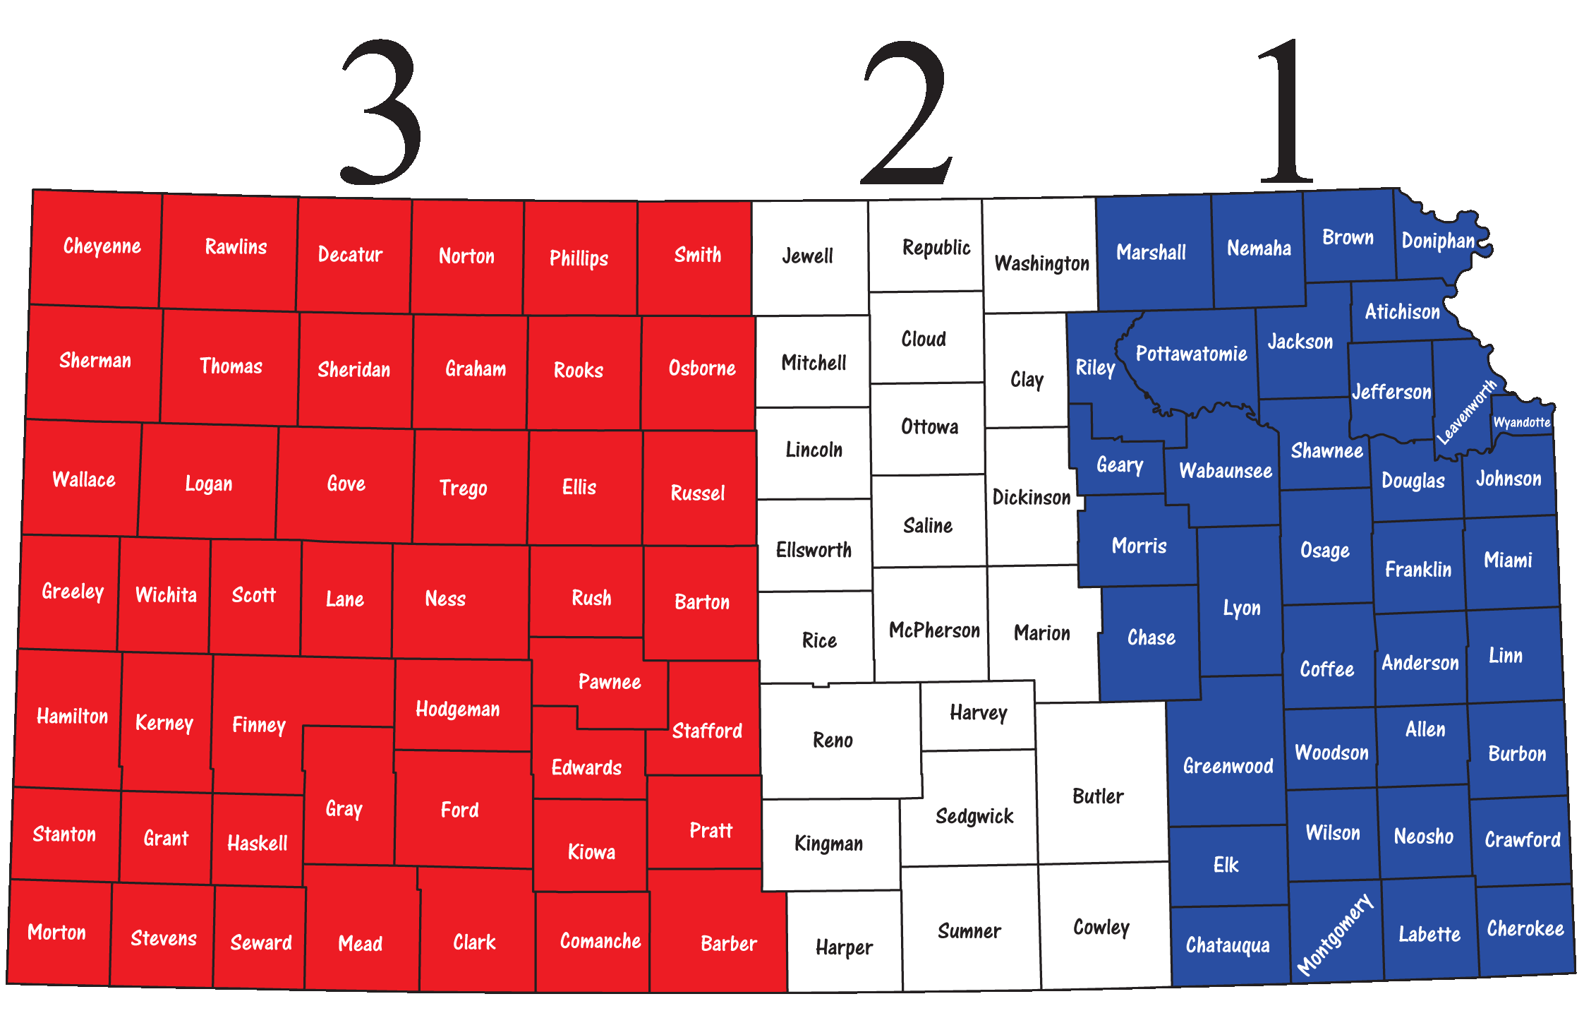

KANSAS REGIONS
*Counties in each region are listed in the three columns below.

REGION 1 (EAST REGION):  Allen  Anderson  Atchison  Bourbon  Brown  Chase  Chautauqua  Cherokee  Coffey  Crawford  Doniphan  Douglas  Elk  Franklin  Geary  Greenwood  Jackson  Jefferson  Johnson  Labette  Leavenworth  Linn  Lyon  Marshall  Miami  Montgomery  Morris  Nemaha  Neosho  Osage  Pottawatomie  Riley  Shawnee  Wabaunsee  Wilson  Woodson  Wyandotte | REGION 2 (CENTRAL REGION):  Butler  Clay  Cloud  Cowley  Dickinson  Ellsworth  Harper  Harvey  Jewell  Kingman  Lincoln  McPherson  Marion  Mitchell  Ottawa  Reno  Republic  Rice  Saline  Sedgwick  Sumner  Washington | REGION 3 (WEST REGION):  Barber  Barton  Cheyenne  Clark  Comanche  Decatur  Edwards  Ellis  Finney  Ford  Gove  Graham  Grant  Gray  Greeley  Hamilton  Haskell  Hodgeman  Kearny  Kiowa  Lane  Logan  Meade  Morton  Ness  Norton  Osborne  Pawnee  Phillips  Pratt  Rawlins  Rooks  Rush  Russell  Scott  Seward  Sheridan  Sherman  Smith  Stafford  Stanton  Stevens  Thomas  Trego  Wallace  Wichita

